
Celstream Technologies Private Ltd.
Project: |  |  |  | Razor RCL Test/Demo Application
Title: |  |  |  | RCL Test - GUI usage document
Version: |  |  |  | Draft
Issue Date: |  |  |  | October 3, 2000
DCN:
Razor RCL Test GUI-Usage Document approved by
Razor RCL Test GUI Document reviewed by
Revision Control Sheet
REV | DCN # | DATE |  |  | AUTHOR | SECTIONS | DESCRIPTIONN
0.1 |  | Oct 3, 2000 |  |  | Sabina Rego |  | 1st Draft
0.2 |  | Nov 6, 2001 |  |  | Sabina Rego |  | 2nd Draft (Added documentation for new Script functionality)

Overview
The Router Control Language (RCL) Client is a software task that provides the capability to Razor applications to interface to, and control the existing SMS7000 router.
The goal of Phase-1 is to develop the Panel Server that manages the interface between the control panels and the routing engines. The routing engine could be the legacy SMS7000 system or the Razor router controller. The RCL Client Library will provide a set of APIs, which can be used by the Razor application to communicate with and control the SMS7000 system. The RCL client will implement the RCL protocol specifications. RCL Client will support Serial RS-232 or Ethernet as the external communication medium.
The RCL Test Application will be used to test/demo the working of the Razor Router Control Language and Native Protocol. It will test the RCL Server (i.e. on the MCPU or Panel Server) and since it uses the RCL Client API to communicate with the MCPU, it serves as a mechanism to test the RCL Client API/Library as well.

DeSCRIPTION
The RCL Test Application will be a dialog-based application running on NT. It will be used to test the functioning of the RCL server (i.e. on the MCPU or Panel Server). The RCL client will interface with the SMS7000 MCPU/Panel Server over Serial and Ethernet.
Hardware
(WinNT PC)

RCL Test/Demo Application

RCL Client Library
RCL / NP Server
(e.g. MCPU or Panel Server)

RS-232 or
Ethernet

The above diagram shows the system architecture where the RCL Test App and the RCL Client & Server fit in. The RCL Test Application is nothing but a type of User Application as mentioned in the RCL Client FDD/HLD. The Test App interfaces to the RCL/NP Server through a set of APIs provided by the RCL library. The external interface could be one of RS-232 or Ethernet. The Test Application and the RCL Client library will work together on an NT target only.

Feature List
- The RCL Test App will have a dialog-based graphical user interface.
- Similar to the SMS7000 GUI, the RCL Test App will have a facility for connecting to the Router when it comes up. It will also provide the facility for the user to disconnect from the MCPU when necessary.
- The GUI will provide a mechanism whereby each API provided by the RCL Client Library can be invoked “individually” and with the help of dialog controls, the GUI will provide the user the facility of selecting different parameters for each command.
- The GUI will display the RCL format of the message being sent to the MCPU. It will also display the RCL format of the message received from the MCPU as well as the response data received, if any.
- The GUI will also provide a mechanism whereby the user can send “multiple” queries at a time. This can be achieved by specifying a script file in which all the commands to be sent are included in a particular format with comma separated variables. The user can also specify a file for logging all the responses received from the Server.

Details of usage

The GUI for the RCL Test program has been designed using MFC Property Sheets and Property Pages.
The user needs to establish a connection between this RCL Client test program and the RCL Server running on the Router. The user also needs to specify the mode for testing. There are two modes available to the user for testing namely,
- User Interface
- Test Script
The entire list of RCL Client APIs provided by the RCL Client library have been categorized into the following:
- Connections
- Query
- Settings
- Status
- Operations
- Subscription
Each of the above items has been represented in the GUI as a Property Page with Tabs for each category. Since the Query APIs are more in number, they have been spread over two Property Pages.
When the GUI comes up, the user is presented with only one Tab namely, the ‘Connections’ Tab. It is in this page that the user specifies the test mode. Depending on which mode the user specifies, the GUI will display the appropriate Tabs.

In the ‘Test Script’ mode, only one additional Tab will come up with the following heading
- Run script
In the ‘User Interface’ mode, the GUI will bring up 6 additional Tabs namely,
- Query
- Query ctd.
- Settings
- Status
- Operations
- Subscription

GUI SCREEN SHOTS

CONNECTIONS TAB
Screen Layout
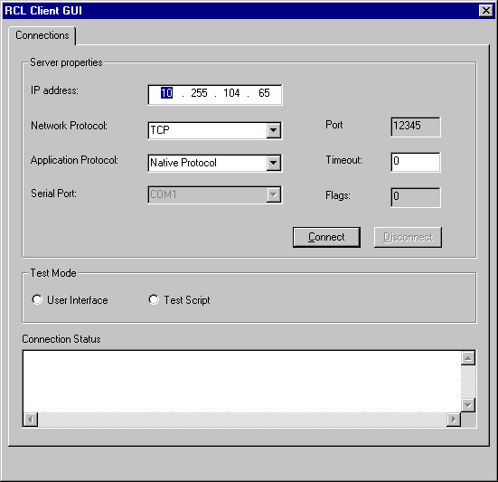

APIs that can be tested:
- Connect(string& hostName, UInt16 portNumber, TECommProtocol commFlag, TEAppProtocol appFlag, Int32
flag=0, Int32 TimeOut=0)
- Disconnect(int smsHandle)

GUI controls:
- IP address: For this, there is an edit control where the user types in the IP address of the server.
- Network Protocol: A combo box has been provided with TCP, UDP and Serial as the options.
- Application protocol: There is a combo box with Native Protocol and Router Control Language as the options.
- Port (using TCP): For this, there is an edit control that is read-only, as the port number has to be ‘12345’.
- Serial Port: There is a combo box with COM1 and COM2 as the options.
- Flag: The OpenCommunication call requires a flag value, hence an edit control, has been provided for this.
- TimeOut: There is an edit control for this too, where the user can specify the timeout value.

Defaults:
Network Protocol = TCP, Application Protocol = Native P, Port = 12345, Flag = 0, Timeout = 0

QUERY TAB
Screen Layout
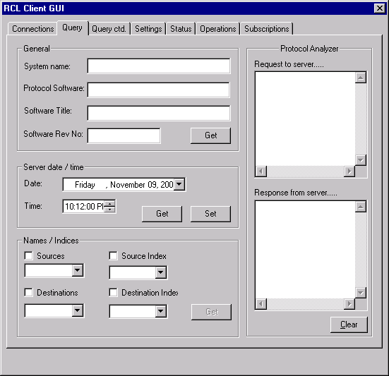
APIs that can be tested:
- QuerySystemName
- QueryProtocolSoftwareTitle
- QuerySoftwareRevNo
- QuerySoftwareTitle
- QuerySourceNames (and Indices)
- QueryDestinationNames (and Indices
- GetDateTime
- SetDateTime

GUI Controls:
System Name/Protocol Software/Software Title/Software Revision: When the user clicks the Get button in the General group box, the name of the processor running on the server is displayed in the System Name edit control. The Software Title and Software Revision are also displayed in their respective edit controls.
Date/Time: There is one group box with a Get button for getting the server date and time. The other one has a date and time picker with a Set button for setting the Server date and time
Sources/Destinations/Source Index/Destination Index: There are check boxes within the Names group box for the user to select which ones he would like to query. The user then has to click the Get button. Once clicked, the get button gets disabled. Any further selection among the check boxes will enable the Get button once again.

QUERY ctd. TAB
Screen Layout:
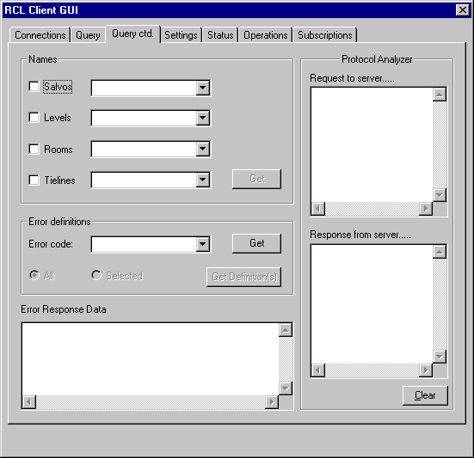
APIs that can be tested:
- QueryLevelNames
- QuerySalvoNames
- QueryErrorDefinition

GUI controls:
Salvos/Levels/Rooms/Tielines: These controls are handled in a similar manner as mentioned above for Sources/Destinations etc. [Note: Room names and tieline names cannot be queried, as the RCL Client library currently does not support it.]
Error Codes: When the user clicks this button, the list of error codes are displayed in the combo box.
Error Definition: The user needs to specify whether he would like to see the error definition for the code currently selected in the combo, or whether he would like to see all error definitions. This he can do with the help of the two radio buttons provided i.e. All and Selected.
Error Response Data: The results of the Error Definition query is displayed in this edit control. If the user clicked the ‘Selected’ radio button, the definition for that particular code is displayed. If he clicked the ‘All’ button, then the definitions corresponding to every code are displayed here.

SETTINGS TAB

Screen Layout
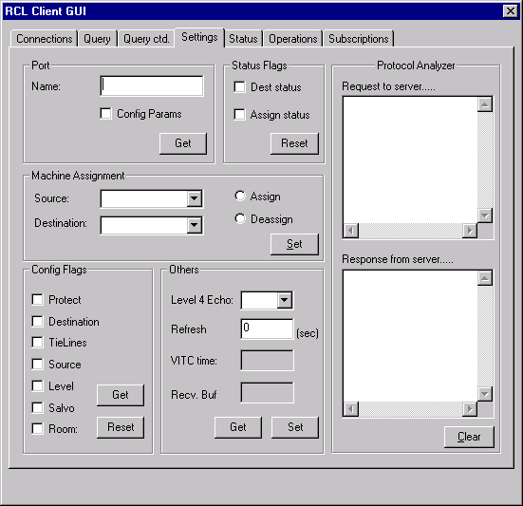
APIs that can be tested:
- GetPortName
- GetPortConfigurationParams
- MachineAssign
- MachineDeAssign
- ResetDestinationStatus
- ResetAssignmentStatus
- GetConfigFlags(int rclTag,Int32 timeOut)
- ResetProtect(int rclTag,Int32 timeOut)
- ResetDestinationChange(int rclTag,Int32 timeOut)
- ResetTieLineChange(int rclTag,Int32 timeOut)
- ResetSourceChange
- ResetLevelChange
- ResetSalvoChange
- ResetRoomChange
- GetRefreshInterval
- SetRefreshInterval
- GetLevel4Echo
- SetLevel4Echo

GUI controls:
Port Name and Port Configuration Parameters: If the user want to see the Port Configuration Parameters in addition to the Port Name, the user needs to check the Config Params checkbox before clicking the Get button in the group box labelled ‘Port’.
Sources and destinations: There are combo boxes for the user to select the source and destination for machine assignment or de-assignment. If the user tries to do an assignment or de-assignment when the combo boxes are empty, the GUI will prompt the user to query for the sources and destinations. I have intentionally not tried to populate the sources and destinations, if the combos are empty because the aim of this application is to test the functionality of the APIs and to be able to record the results. If the query has been executed automatically, the purpose of having a separate Query tab ceases to exist. Hence the user is made to query for sources/destinations if he hasn’t already done so.
Assign and Deassign: There are radio buttons to enable the user to specify an assignment or a de-assignment.
Refresh Interval: When the user clicks the Get button, the Refresh Interval setting is displayed in the edit control. If he changes this value, the Set button gets enabled and the user can click it if he wishes to set a new refresh interval. [Note: If a non-zero refresh interval has been set, the user needs to send a message to the server before this time elapses, or else the NP/RCL connection with the server will be lost. So don’t be surprised if you set it to 10 seconds, then don’t do anything for 10 seconds, and then you find that you cannot communicate with the server anymore. This is a feature supported by NP/RCL.
Level 4 Echo: When the user clicks the Get button, the edit control will display whether it is ON or OFF. The user can change this setting and then click the Set button.
Config Flags: When the user clicks the Get button, the edit control will display the Config flag value in Hex. The interpretation of this value will be displayed in the ‘Message Received’ edit control.
Flags (Reset): Check boxes have been provided for the user to select which flags he wishes to reset. After checking the necessary flags, he has to click the Reset button.
Note: The following controls have been provided in the Settings Tab, but cannot be used as the RCL Client library presently does not support the corresponding messages.
- VITC time
- Receive Buffer Size
STATUS TAB
Screen Layout:
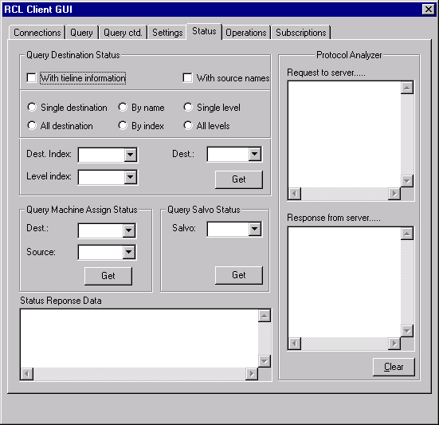
APIs that can be tested:
- QueryDestinationStatus // QC, QD, Qd, QJ, Qj, QL, Ql
- QuerySalvoStatus

GUI controls:
This tab has several controls, as there are many different ways of querying destinations status.
With tieline information: This check box needs to be checked if the user wishes to obtain destination status with associated tieline information.
With source names: This check box needs to be checked if the user wishes to get the actual names of the sources taken to the specified destination(s). If he is not interested in source names, he can leave this unchecked. In such a case, the server will send a NO_XPT status against the source.
By name / Byindex: These radio buttons are intended for the user to specify whether he will be providing the name s of the destination or the index. They are not used if the Tieline Information check box is checked, since in such a case m the destination is always passed by name.
Specific destination / All destinations: The user must select the Specific radio button if he wants the status for a particular destination. If he wants the status for all destinations, he needs to select the All destinations radio button.
Specific level / Combined levels: This is for the user to specify whether he wants the status of a destination on a particular level or whether he would like a combined level status.
Destination/Level/Destination Index/Level Index: These combos will be enabled/disabled accordingly depending on which parameters are needed. The user needs to make the necessary selections form these combo boxes. The user finally needs to click the View Status button to obtain the required status. The status information will be displayed in the Status Response Data edit control at the bottom of the screen.
Assignment Status: There is a group box for querying the assignment status for a given destination. The user must select the destination from the combo and then click the View Status button for that query. The resulting status will be displayed in the Assignment edit control i.e., either ENABLED or DISABLED.
Salvo Status: The user needs to select the salvo from the combo box and then click the appropriate View Status button. The resulting status will be displayed in the Status Response Data edit control below.

OPERATIONS TAB
Screen Layout:
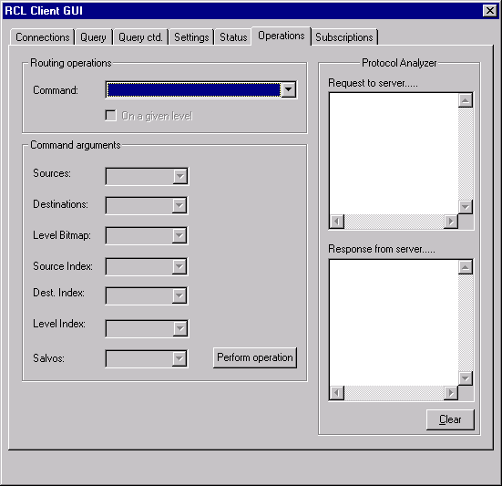
APIs that can be tested:
- Chop
- ClearTieLines
- Protect
- UnProtect
- Take // TD, TI, TA, TJ
- TakeMonitorDestination (for NP and RCL)
- TakeSalvo
GUI controls:
Command: This combo box has a list containing the type of operation the user wishes to perform. The options are: Chop, Protect, Take Destination, Take Destination Index, Take Monitor Destination, Take Salvo & Unprotect.
Command arguments: The following combo boxes have been provided and will be enabled/disabled depending on which arguments the selected operation requires.
- Sources
- Destinations
- Level Bitmap
- Source Index
- Destination Index
- Level Index
- Salvos
On a given level: This checkbox is enabled for certain operations that require the user to specify whether the request is for a given level or for all levels.
The user finally needs to click the Perform Operation button for the command to actually get executed.

SUBSCRIPTION TAB
Screen Layout
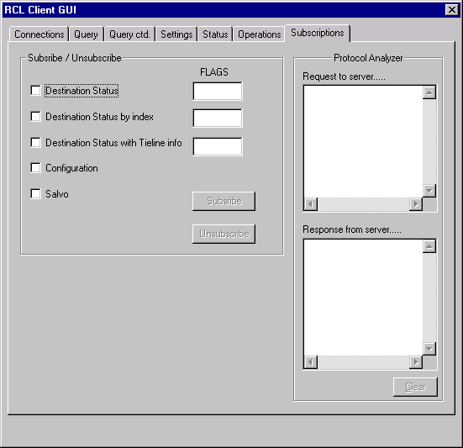
The RCL Client Library currently supports none of the Subscription commands. Hence this Tab is non-functional for the moment.

RUN SCRIPT TAB
Screen Layout
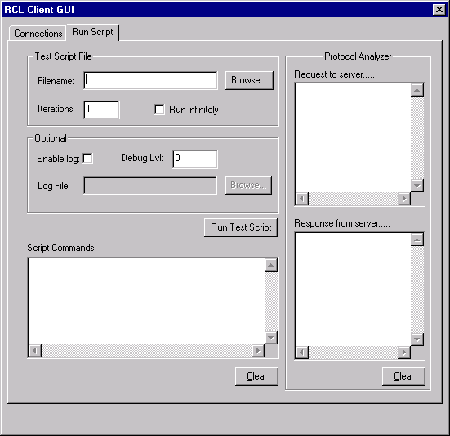

GUI controls:
Test Script File: An edit control labelled ‘Filename’ has been provided to display the Test Script File selected by the user using the ‘Browse’ button.
Iterations/Run Infinitely: If the user wishes to run the Test Script File ‘n’ number of times, he can specify the no. of iterations in the ‘Iterations’ edit box. If the user wants the test script file to be run infinitely, he can check the ‘Run Infinitely’ checkbox. The no. of iterations is 1 by default. Checking the ‘Run Infinitely’ checkbox will cause the Iterations value to change to 0. Likewise, specifying a value non-zero value in the Iterations checkbox will cause the ‘Run Infinitely’ checkbox to be unchecked.
Enable Log: This is a check box that the user can check if he wants the Server response data to be logged to a file. Selecting the ‘Enable Log’ checkbox will result in a Browse button being enable for specifying the name of the log file.
Log file: This is an edit control that will display the log file specified by the using the Browse button. If the user types in a path for a file which does not exist, the format needs to be <drive>:\\<dir>\…….. e.g. C:\\logfile.txt or D:\\MyFolder\RCLserver.log
Debug Level: The value typed in this edit box will be used to determine the level of detail to which the Server responses are logged to the specified file. This value can range from 0 to 4. Specifying a value of 0 will result in an empty log file, while 4 will result in the maximum amount of logged data.
Run Script: After all the above selections and values are typed in, the user simply needs to click the ‘Run Script’ button to initiate the running of the Test Script File.
Script Commands: All the commands read from the Script File will be displayed in this window. Note: If lines in the Script File are preceded with a ‘#’, these lines are considered as commented entries and will be ignored during execution.

NOTE:
- The API mentioned below is called every time a request is sent to the MCPU. This is because the application has a receiving thread that waits for responses from the MCPU that it can recognize. To do this, it needs to continuously invoke this API.
readRCLConnection(int hSMSHandle,list<URCLMessageData>&list_URCLMessageData,
UInt16 usRCLMessagesize,UInt16* respType,UInt16* rclTag,UInt16 usReadFlags, Int32 lTimeout)
- In all the Tabs except for Connections, there is a Protocol Analyzer section to the right of the screen. This has two edit controls:
Request to server: The RCL format of the message sent to the server is displayed here.
Repsonse from server: The RCL format of the message received from the server is displayed here. It may also
display response 'data' in certain cases.

HOW TO CREATE A VALID SCRIPT FILE

- Create a normal text file.
- Each command should be types on a new line and must be preceded with the word “transmit” or just ‘t’.
- The commands currently supported by the RCL Server are:

